**Ideal Twist Data Set**

**Nicole A. Pettingill, Nikolas S. Zawodny, Christopher S. Thurman, Leonard V. Lopes**

**NASA Langley Research Center, Hampton VA, 23681**

**Contents of Release**

2021 AIAA SciTech Forum Paper <https://arc.aiaa.org/doi/10.2514/6.2021-1928>

Figures directory .png formatted figures

RawData directory .csv formatted raw data files (microphone, load cell, laser sensor tachometer analog and laser sensor tachometer ttl)

Processed_Values_SHAC002.xslx Tabulated values of processed results published in paper

TestSummary Tab A summary of all the experiment conditions that were presented in paper.

RawDataFiles Tab Description of raw data files included in release. Tare raw data files are not included, but tare load values are provided.

MicLocations Tab Table of SHAC microphone locations.

FigXX Tabs Tabulated figures. Columns are displayed in order of appearance in legends. For certain figures, experiment and prediction data are split up into two tabs. For further information on data see corresponding Figures in paper.

IdealTwistDataSet.docx Document describing data released.

Pg. 2 Experiment Rotor Performance Figures

Pg. 3 Experiment Acoustic Results Figures

Pg. 9 Broadband Noise Predictions Figures

**Experiment Rotor Performance**

Fig. 7:

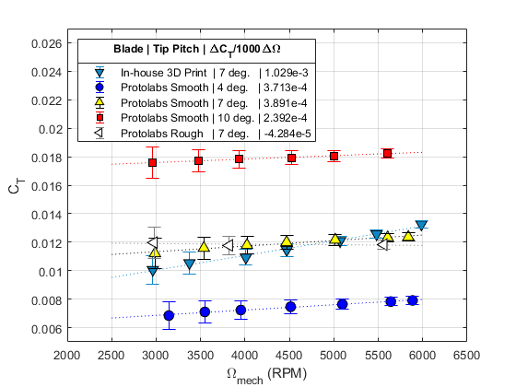

Figs. 8a,b:

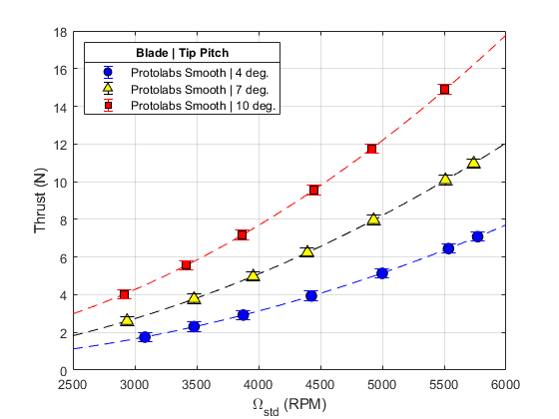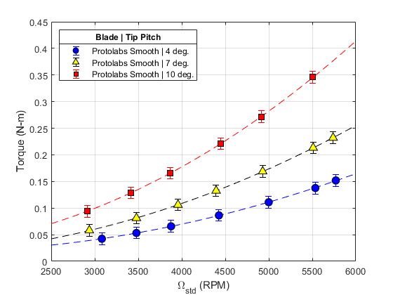

Note about uncertainty:

For dimensional loads, uncertainty is the bias uncertainty defined by the manufacturer. It is assumed that the load cell is the only source of error, which is a safe assumption as other quantities have uncertainties that are negligible in relation.

**Experiment Acoustic Results**

Fig 11:

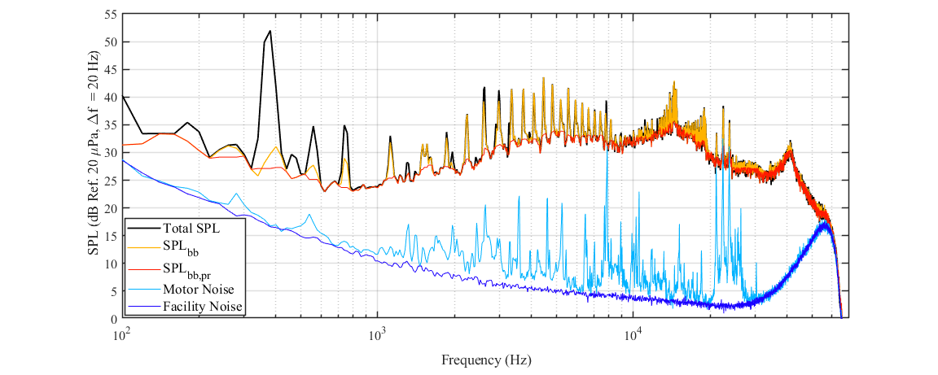

Fig 12:

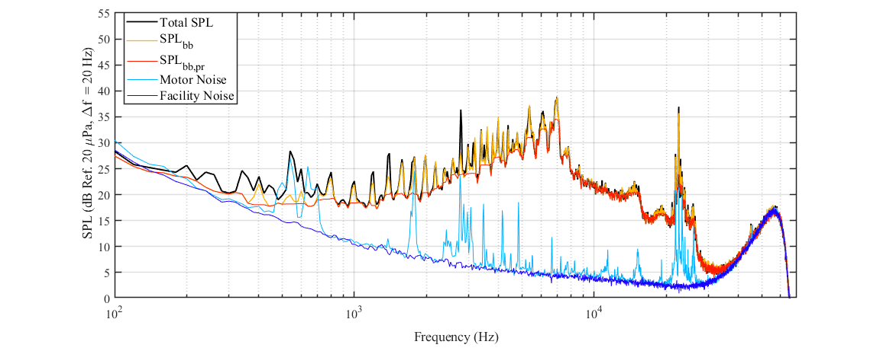

Figs. 13a,b:

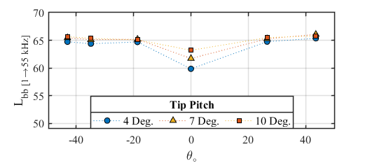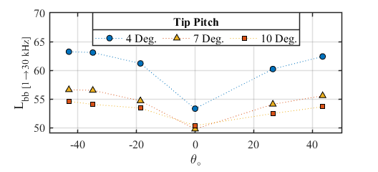

Fig. 15 (*multiple plots in one Excel tab, see Excel column labels for the defined integration ranges)

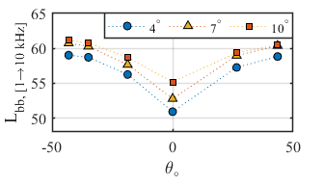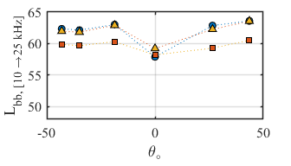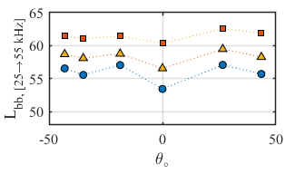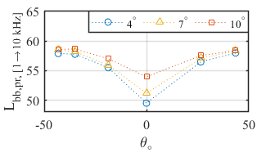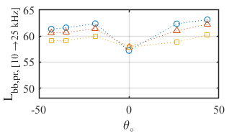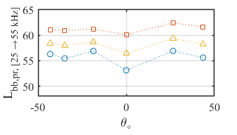

From paper:

Figure 15 shows OASPL plots for the three tip pitch conditions at approximately 5500 RPM, integrated over several frequency ranges. The integration ranges are: 1 kHz ≤ f ≤ 10 kHz, 10 kHz ≤ f ≤ 25 kHz, and 25 kHz ≤ f ≤ 55 kHz.

Colored symbols use residual broadband signal with peaks (Lbb), while clear symbols use residual broadband signal with peaks removed (Lbb,pr).

Fig. 14:

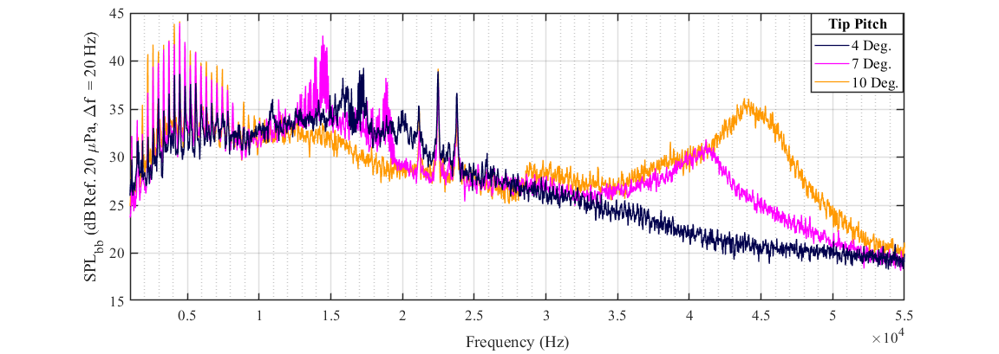

Fig. 16:

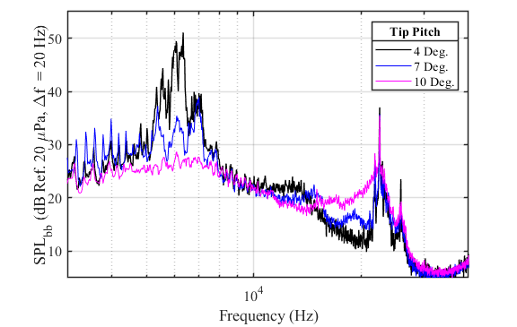

Fig. 17a:

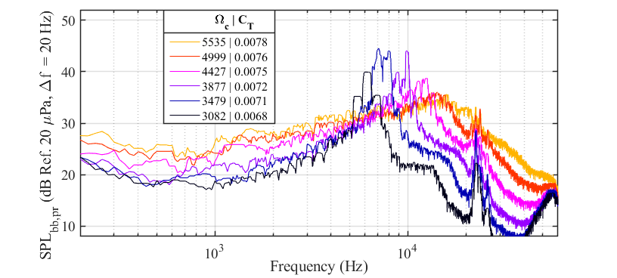

Fig. 17b:

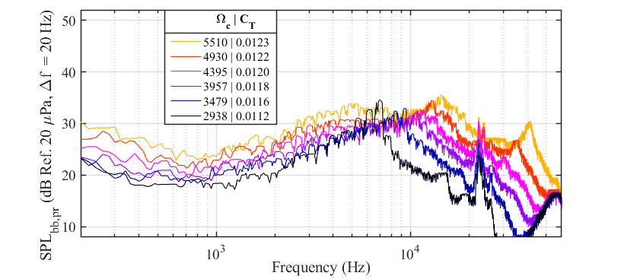

Fig. 17c:

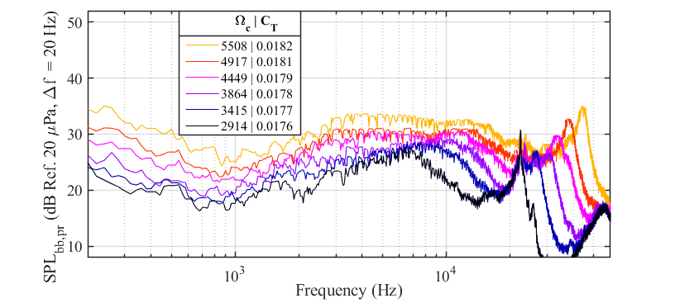

Figs. 18a,b:

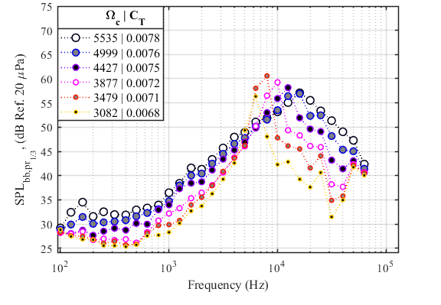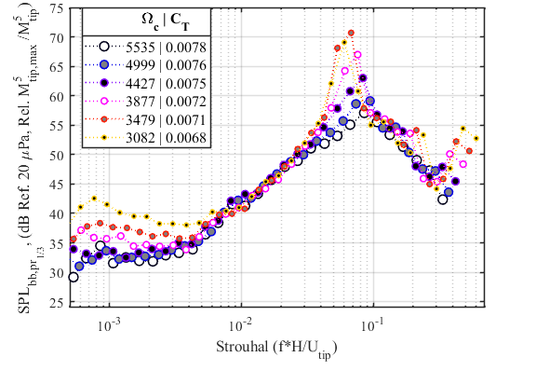

Figs. 18c,d:

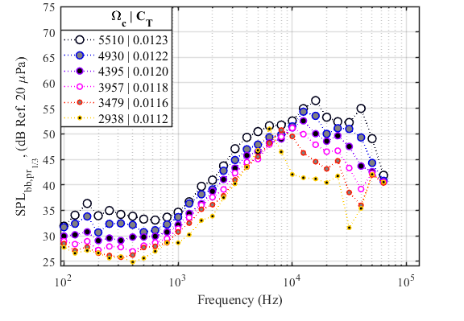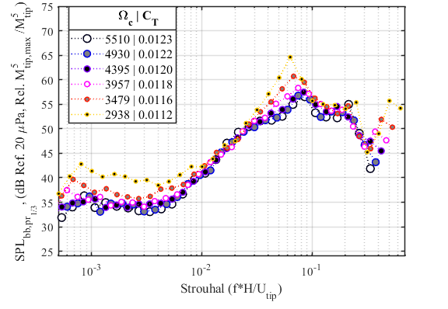

Figs. 18e,f:

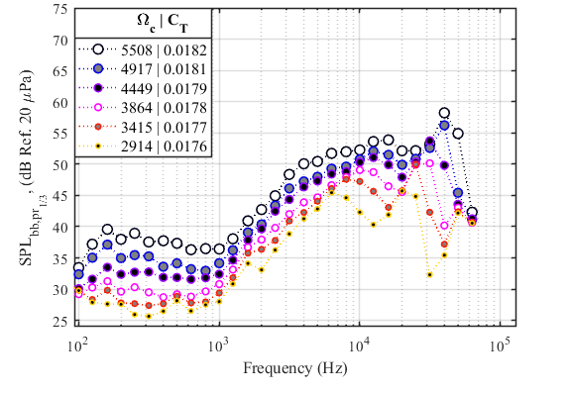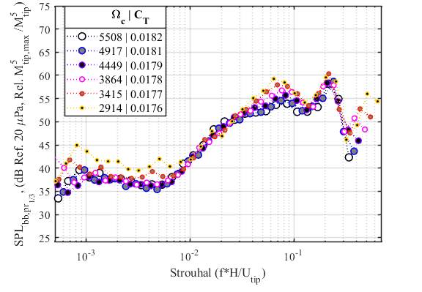

Fig. 19a:

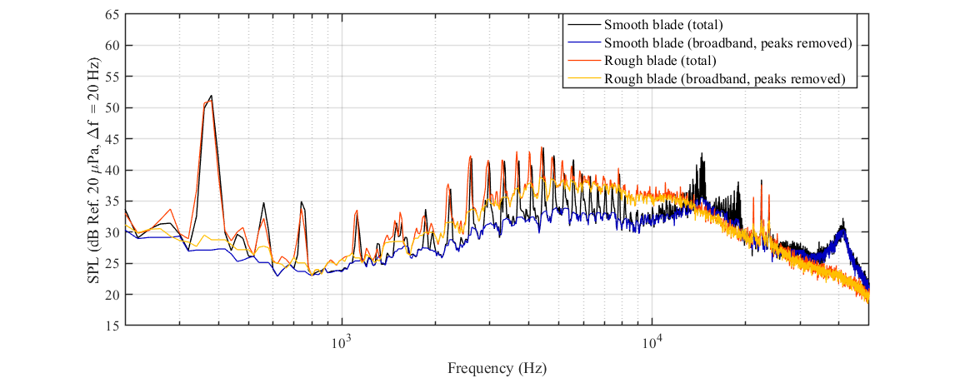

Fig. 19b:

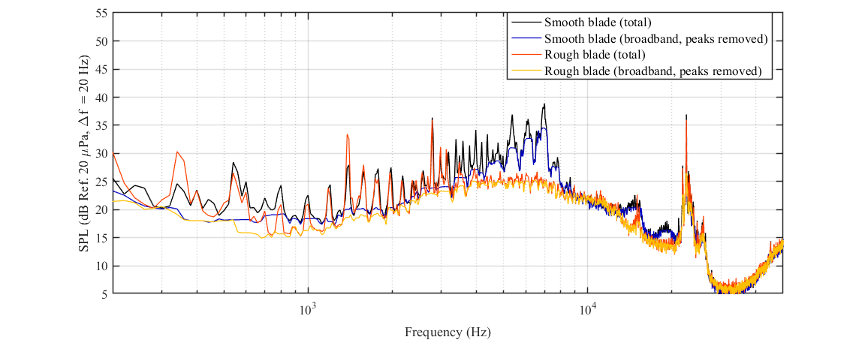Figs. 20a,b:

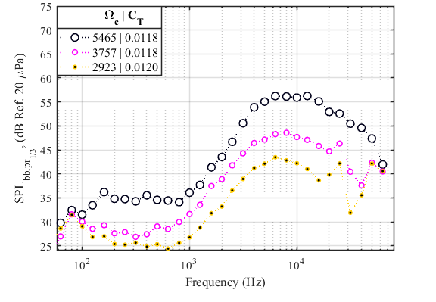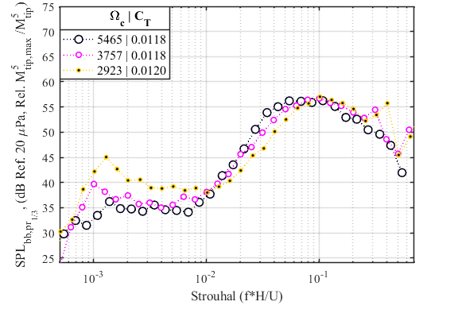

Fig. 21b: (*separated out experiment and prediction data)

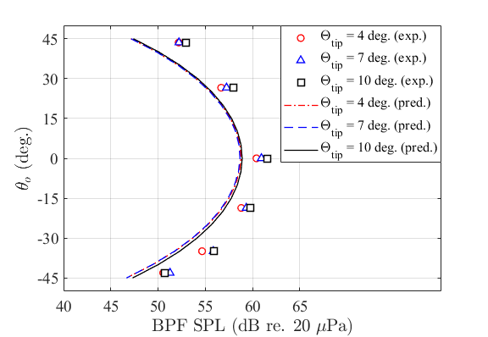

**Broadband Noise Predictions**

Raw data files are included for the following cases.

From paper:

The current prediction method is limited to one-third octave bands, but it is compared to the narrowband experiment with Δf = 20 Hz. This is done by dividing the energy from the one-third octave bands by the number of bands in Δf = 20 Hz.

Fig. 22c: (*separated out experiment and prediction data)

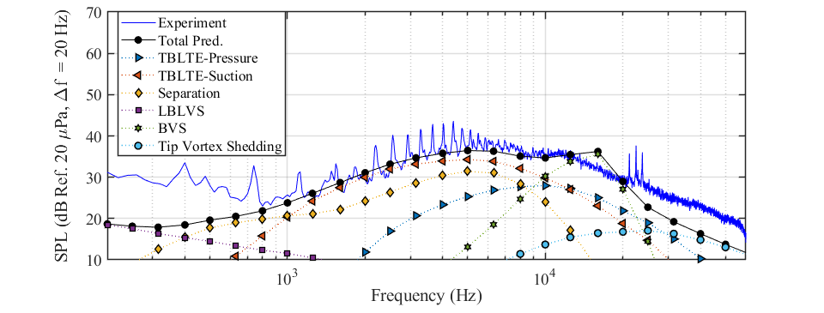

Fig. 23c: (*separated out experiment and prediction data)

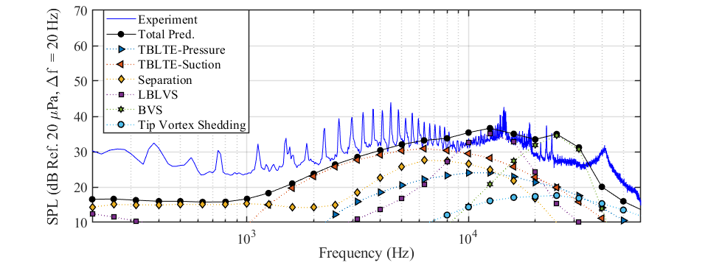

Fig. 24b: (*separated out experiment and prediction data)

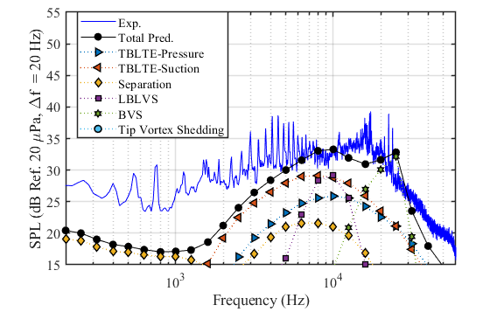

Fig. 25b: (*separated out experiment and prediction data)

